Tandoori Paneer tikka:

Image:

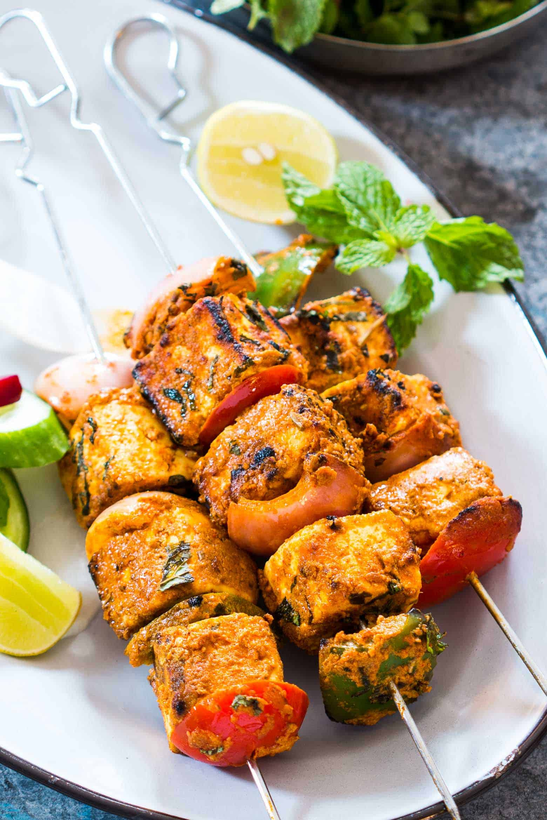

Description:

What is paneer

Paneer is literally a two ingredient cheese. You just need some full fat milk and a souring agent like lemon juice or vinegar to curdle it. I have an easy peasy, [*step by step tutorial to make paneer at home*](https://myfoodstory.com/make-homemade-paneer-cottage-cheese-15-minutes/).

What is paneer tikka:

Just in case you aren’t familiar with our favourite appetizer, tandoori paneer tikka is marinated skewers of paneer which are grilled in a [*super hot tandoor (or traditional clay oven)*](https://en.wikipedia.org/wiki/Tandoor). It’s spicy, juicy, light and slightly smoky. Its like a vegetarian alternative to tandoori chicken, fish or [*prawn tikka*](https://myfoodstory.com/the-best-tandoori-prawns-recipe/) if you’ve tried those.

Recipe Overview

Chunks of paneer, a type of [fresh cheese](https://en.wikipedia.org/wiki/Types_of_cheese#Fresh.2C_whey_and_stretched_curd_cheeses), are marinated in spices and are then arranged on a stick with [capsicums](https://en.wikipedia.org/wiki/Capsicum), [onions](https://en.wikipedia.org/wiki/Onion) and [tomatoes](https://en.wikipedia.org/wiki/Tomato). These sticks are grilled in a tandoor and the dish is thereafter served hot, seasoned with [lemon juice](https://en.wikipedia.org/wiki/Lemon_juice) and [chaat masala](https://en.wikipedia.org/wiki/Chaat_masala" \o "Chaat masala).[[8]](https://en.wikipedia.org/wiki/Paneer_tikka#cite_note-sk09-8) It is sometimes accompanied by [salad](https://en.wikipedia.org/wiki/Salad) or [mint chutney](https://en.wikipedia.org/wiki/Mint_chutney).[[9]](https://en.wikipedia.org/wiki/Paneer_tikka#cite_note-sk-9) [Tikka](https://en.wikipedia.org/wiki/Tikka_(food)" \o "Tikka (food)) dishes traditionally go well with mint chutney.[[10]](https://en.wikipedia.org/wiki/Paneer_tikka#cite_note-po07-10) The paneer, though tender, has a crisp singe on the surface.[[11]](https://en.wikipedia.org/wiki/Paneer_tikka#cite_note-thc06-11)

Ingredients:

* 2 cups Paneer cubes ((Cottage Cheese), cut into 1 inch cubes)
* 1 medium sized onion (cut into 1 inch cubes)
* 1 capsicum (deseeded and cut into 1 inch cubes)
* 1 large tomato (deseeded and cut into cubes (optional))
* chopped Coriander or Cilantro,
* Lime juice for topping

Nutritional facts:

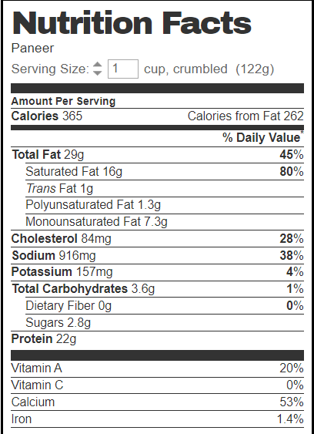

Health benefits:

* Rich in Protein.
* Cottage Cheese Strengthen Bones And Teeth.
* Maintains Blood Sugar Levels.
* Good For Heart **Health**.
* Improves Digestion.
* Rich Source of Folate.
* Boosts Weight Loss.

Recipe: <https://myfoodstory.com/tandoori-paneer-tikka-oven-recipe/> or the pdf in local drive

References:

<https://myfoodstory.com/tandoori-paneer-tikka-oven-recipe/>

<https://en.wikipedia.org/wiki/Paneer_tikka>